**Mindsports Exco Bonding 2024 Post Event Report**

SIMMindsports Club organized the Exco Bonding for the excos of the new term on 9th November 2024 from 4:00 pm to 9:00 pm at Marina Barrage Green Roof. This is the second event held by Mindsports Club for this term. In total, 7 out of 7 people who signed up came for the event. The objective of this bonding event is to bring the EXCOs closer together and help them open up so they have an easier time working with one another in the future.

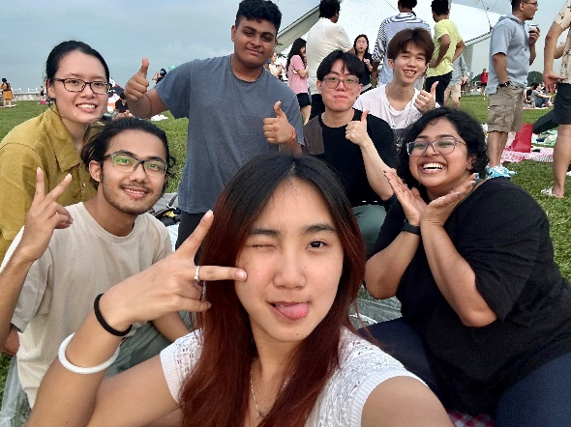The bonding this year was held at Marina Barrage Green Roof in a picnic style. The event started at 4:00 pm but with some delays due to the rain. We started off with some icebreaker games to get comfortable with each other. After that, we just bonded each other over some snacks and drinks. We also played Frisbee on the field with fellow exco members throughout the event. The picnic seemed to have helped a lot in getting each other closer than expected.

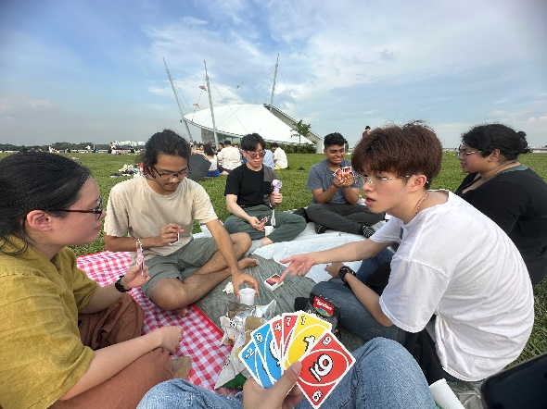

Later, we proceeded to have a discussion about the club and its future direction. Some issues and future events to host were discussed as well as details about current or upcoming events. When it was 7pm, we ordered pizza and enjoyed our dinner together after the sunset. Lastly, we took some group photos and packed up for the day.

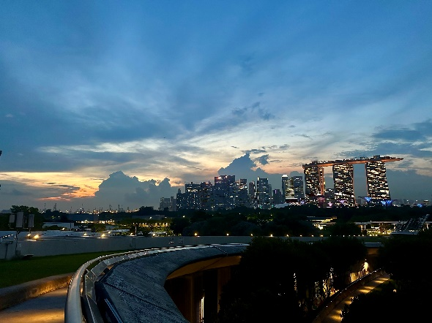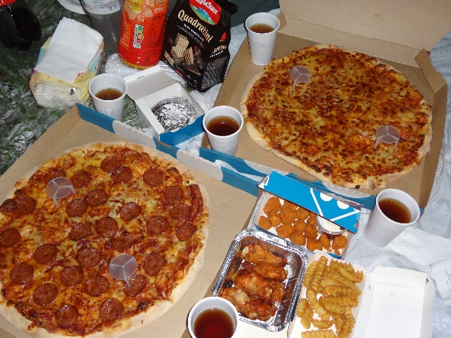

The exco bonding was a great way for the excos to bond together with each other. It was a great experience as the participants got closer to each other more than expected. When club matters were discussed, it was more clarifying and easier to discuss than online in the group chat. We each talked about our opinions on the club matters and its future direction, allowing each other to know about themselves and have a consensus on certain matters. The picnic style seemed to be more comfortable and relaxing for everyone and hence, they spoke up their minds a lot. For the event, we could have prepared more icebreaker games as it would be more fun for the participants. Each participant also could have prepared some ideas ahead of time so that everyone can discuss more effectively. Overall, the exco bonding event held outside had a positive effect on the exco members and also achieved the objectives of this event. Therefore, this event could be said to be successful.

